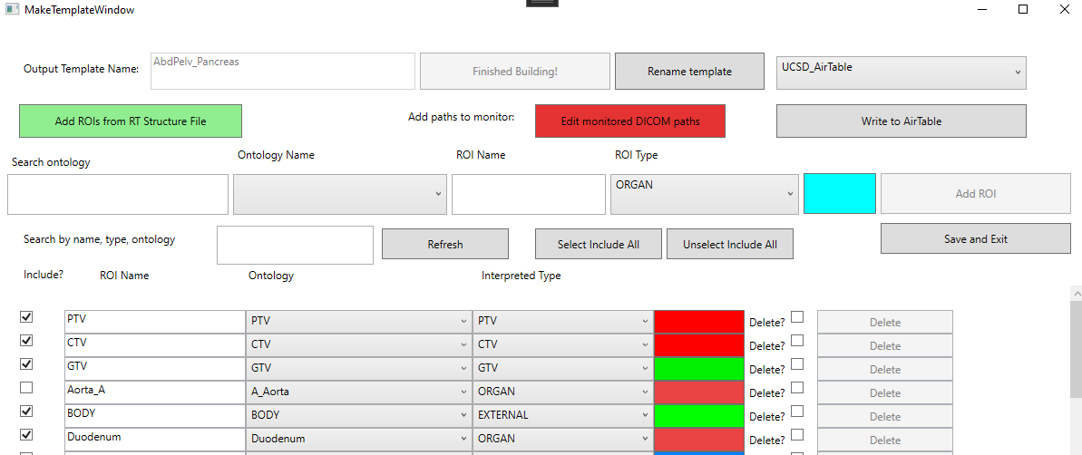

Figure 2: Edit within the template window for ‘AbdPelv_Gyn’. The user can add targets, and see the presented ROIs listed below. Here, the ‘PTV’ is about to be added.